SUWETHA M 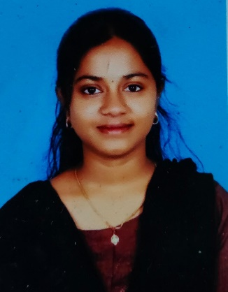
+91 84385 93606 | suwethaswe2@gmail.com | Chennai – 600087 | github.com/Suwetha21

Aspiring JAVA Full Stack Developer with strong skills in both Java and Web technologies. To create innovative and responsive web solutions through efficient front-end and back-end development. Highly motivated to apply problem-solving skills, creativity, and technical expertise to build innovative, scalable software solutions.

EDUCATION
Bachelor of Engineering (BE) - Electronics and Communication Engineering | PSNA College of
Engineering and Technology, Dindigul | 2021 – 2025 | CGPA: 8.7
HSC - St. James Matriculation Higher Secondary School | Trichy | 2019 – 2021 | Percentage: 88.6%
SSLC - St. Vincent Matriculation Higher Secondary School | Trichy | 2018 – 2019 | Percentage: 91%

TECHNICAL SKILLS
- Programming Languages: JAVA(Core JAVA & J2EE)
- Core JAVA-Concepts Like Arrays, Strings, OOPS, Data Structures & Algorithms.
- J2EE- JDBC, Hibernate, JSP, Servlets.
- Web Technologies: HTML, CSS, JAVASCRIPT.
- Software Development Life Cycle: Knowledgeable in all phases from Planning to Implementation.
- Database: SQL (Joins, Sub-queries, Grouping, DDL/DML/TCL), MySQL.
- Tools & Platforms: Eclipse, VS Code, GIT, GIT-hub, SQL*Plus, MS office.

INTERNSHIP
Front-End Development Intern
THE DEVELOPERS ARENA (OCT – NOV) 2025
- Completed a 30-day internship focused on front-end web development.
- Designed and developed a responsive personal portfolio website using HTML, CSS, JavaScript.

PROJECTS
Food Ordering App (Java)
- Built a Java-based console application simulating a food ordering system.
- Implemented features like menu browsing, order placement, and billing.
- Used GIT-Hub for version control, simulating collaborative development.

Personal Portfolio Website
- Built a website using HTML, CSS, and JavaScript to showcase skills, projects, and achievements.
- Applied UI/UX principles for an engaging design and cross-device compatibility.
Student Course Management System (SQL)
- Designed a relational database to manage students, courses, faculty, and enrollments.
- Implemented SQL queries, joins, triggers, and stored procedures for efficient data retrieval.

SOFTWARE TRAINING
QSPIDERS - JAVA Full Stack Development
Trained in Java Full Stack Development with complete practical, real-time project experience.

CERTIFICATIONS
- Java- Course Era.
- Power BI – workshop.
- WEB development- Nitroware Technologies.

INTERPERSONAL SKILLS
- Strong Analytical thinking and Problem Solving.
- Team collaboration and Excellent Communication.
- Quick learner and Adaptable to new technologies.
- Ability to Prioritize tasks and Responsible.

